Table of Contents

2

2

2

2

1.1.3 ER Digram4

1.1.4 Views4

1.2. Task Assign to Members4

1.2.1 Abdul Haseeb Khan And Khanzada Haider Ali:4

1.2.2 Ashfaq Rahim And Hasssan Shah Nawaz8

1.2.3 Fahad Afzal, Imad Ahmed10

1.2.4 Awais And Sardar Badar13

Note:14

# Hotel Management System

## Database Planning

We can Divide our Hotel Management System Into Following Sections.

### Mission Statement

*“The purpose of Hotel Management System is to help out Stack-Holders in Manage them room bookings and optimize their profit. The system will keep track of the rooms and generate information related to finance, room booking, and Generate financial report.”*

### Mission Objective of Database

Mission Objective of the database is

* To maintain (Enter, Update and Delete) data on rooms
* To maintain (Enter, Update and Delete) data on Customer
* To maintain (Enter, Update and Delete) data on Managers
* To maintain (Enter, Update and Delete) data on Customer Activities
* To maintain (Enter, Update and Delete) data on Bookings
* To maintain (Enter, Update and Delete) data on Finance
* To maintain (Enter, Update and Delete) data on Free Rooms
* To maintain (Enter, Update and Delete) data on Booked Rooms
* To maintain (Enter, Update and Delete) data on Room Cancellation
* To maintain (Enter, Update and Delete) data on Branch
* To maintain (Enter, Update and Delete) data on Employees
* To maintain (Enter, Update and Delete) data on Wages
* To maintain (Enter, Update and Delete) data on Viewing
* To Search on rooms
* To Search on Customer
* To Search on Finance
* To Search on Branch
* To Search on Employees
* To track on Rooms
* To track on Client
* To track on Free Rooms
* To track on Booked Rooms
* To report on rooms
* To report data on Customer
* To report on Bookings
* To report on Finance
* To report on Branch
* To report on Employees

### ER Digram

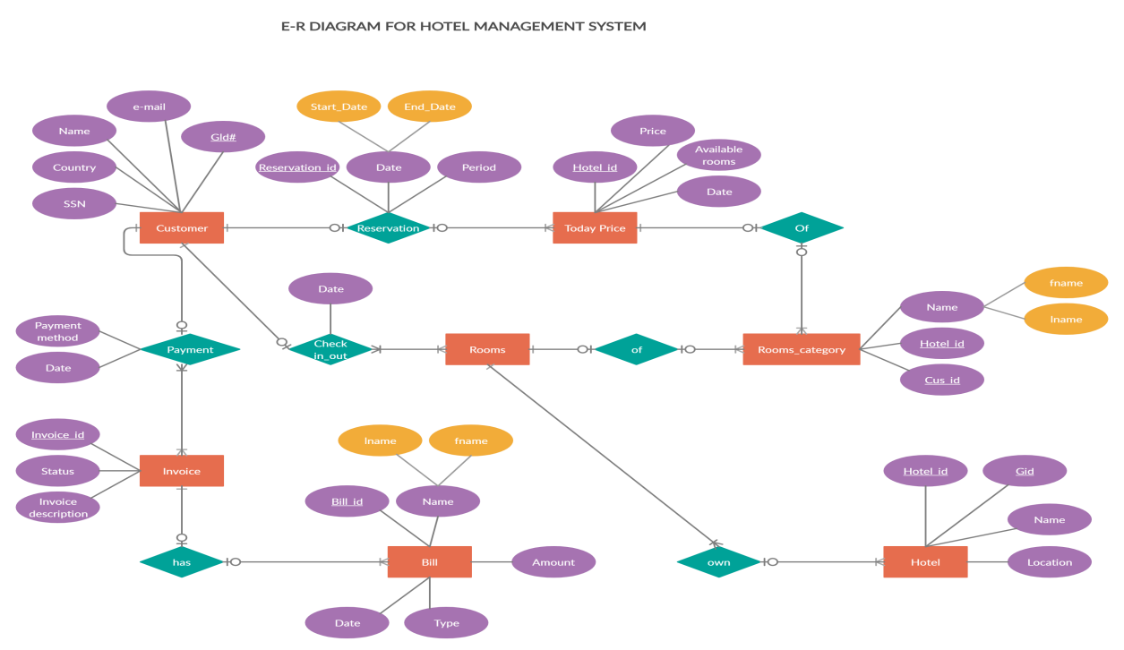

### Views

There is only one view in our Systems

## Task Assign to Members

### Abdul Haseeb Khan And Khanzada Haider Ali:

Abdul Haseeb Khan and Khanzada Hadier will design and develop the Login Functionalites in Our Hotel Managemnt System by interacting with database to validate the user. This task does not include any java program or moduling. It’s purely SQL related. We will be able to finish our tasks in the project as soon as we learn the queries required to do our task. Our task includes the handling of making of new Ids by the users. This includes first time making of a new id which includes unique usernames as provided by the user and the password. After making of the new ids the users can log in through the data they provided. This will include cross checking of the usernames and passwords across the ids of the users. Our work will take almost a week if we know the certain queries which we will learn as the classes go by.

**Mission Objectives:**

* To maintain (Enter, Update and Delete) data on Customers
* To maintain (Enter, Update and Delete) data on Managers
* To maintain (Enter, Update and Delete) data on Employees

**MAJOR USER VIEW (UI PROTOTYPES)**

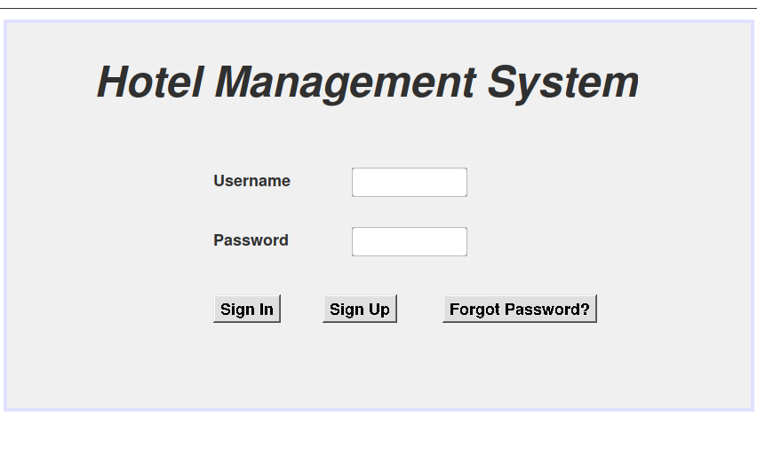

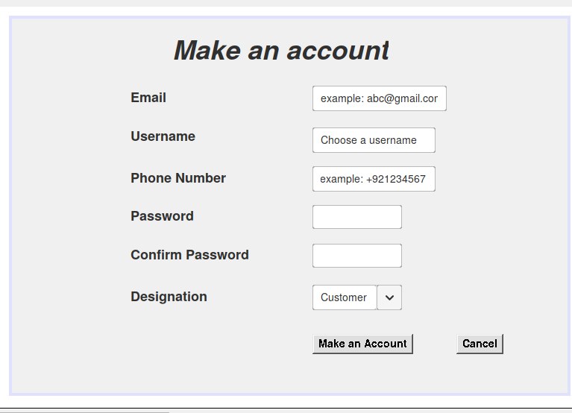

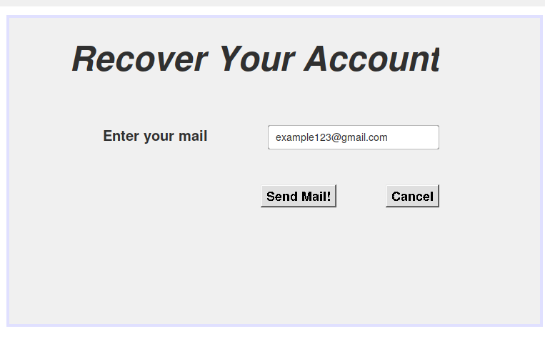

**ER DIAGRAM:**

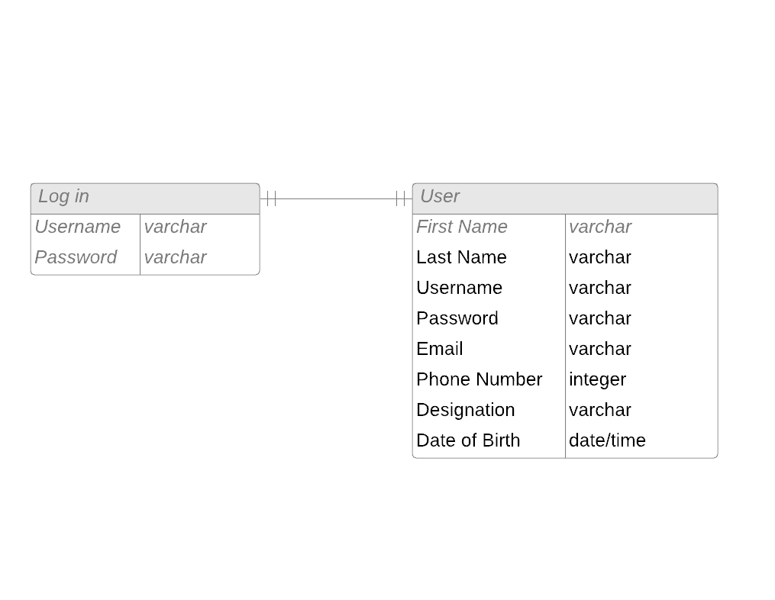

### Ashfaq Rahim And Hasssan Shah Nawaz

**Mission objective modules of our project:**

Develop and design the dashboard functionalities after user will login the system.

**SCOPE:**

We want to choose the metrics that matter. We want to keep it visual. We want to make it interactive for collaboration. We want to pull data from all sources to get the full picture and keep the dashboards up to date or refreshed. And, finally, we want to make it simple to access and easy to use.

**TIME AND COMPLEXITY:**

The time taken for developing and designing dashboard is 2 months. Building an effective dashboard according to best practices for dashboard design is the culmination of a comprehensive process that would usually include gathering requirements, defining, and creating a data model. However, the importance of proper dashboard design should not be understated. Poorly designed dashboards could fail to convey useful information and insights and even make the data less comprehensible than it was originally.

**MISSION STATEMENT:**

The mission of our hotel is to provide outstanding lodging facilities and services to our guests. Our hotel focuses on individual business and leisure travel, as well as travel associated with groups meetings. we emphasize high quality standards in our rooms and food and beverage divisions. We provide a fair return on investment for our owners and recognize that this cannot be done without well trained , motivated and enthusiastic employees.

**MISSION OBJECTIVE:**

* To maintain (Enter, Update and Delete) data on Rooms
* To maintain (Enter, Update and Delete) data on Customer
* To maintain (Enter, Update and Delete) data on Bookings
* To maintain (Enter, Update and Delete) data on Payment
* To Search on rooms
* To Search on Customer
* To Search on Bookings
* To Search on Payment
* To track on Rooms
* To track on Customers
* To track on Bookings
* To track on Payments
* To report on rooms
* To report data on Customer
* To report on Bookings
* To report on Payments

**MAJOR USER VIEW (UI PROTOTYPE):**

Reviewed by:

Fahad Afzal, Abdul Haseeb Khan

Comments:

All good.

**DASHBOARD ER DIAMGRAM:**

### Fahad Afzal, Imad Ahmed

**Task:**

Imad and Fahad must design and develop the room status and selection that will include available rooms, new client’s insertion part, available and booked rooms and the price of rooms and client information related part.

**Hotel Management System**

**Scope:**

We will create client`s residential system. This module will help the client to make his/her choice of reservation easy. It will provide the client with the necessary information about suite and rooms which he/she needs to know.

**Development Time:**

This module will take about three (3) and a half month (1/2) to complete.

**Complexity:**

Since we are in a learning phase so our module can have a lot of flaws. Despite our hard work we will not be able to cover all holes. We`ll be using Java net-beans for our module which will use different concepts of coding.

**Mission Statement:**

We will make client residential module.

**Major View:**

For our convenience we are dealing with only one major view.

**Conclusion:**

Our Project is about Hotel management system and Imad and Fahad will deal the client`s residential part. As the client demands about its residency we`ll provide the client several option for example which type suite clients want to book he/she can book king size suite or medium size suite, whether he/she want double bed or not, does the client want attach jacuzzi with steam bath or not. How much the client wants to stay in our hotel, two days or 3 days or a week. According to our client’s information about stay in hotel we`ll offer him/her the different deals. If the client often visits at our hotel, we will provide the client premium membership which will reduce his/her booking costs in next trips. Further we will collect client’s personal information as per our hotel policy i.e. Name, permanent address, reason to visit (vocation or business tour), identity proof etc. If the client stays in his/her booked suite for one day or night and had a change of mind and want to change the room or there is an emergency for the client we will provide the client with different facilities and the cost may varies according to situation. If a client is superstitious and want the room of his/her choice, then we will do our utmost effort to provide the client with there choice. If the rooms are under maintenance, we will provide advance notification via email if due to some reason client didn`t read the email we will notify the reception with the information. Furthermore, if a client books a suite and didn`t come to suite and due to some reasons, the client cancels their reservation well provide 70% money back guarantee. The price may vary for different client it depends on client`s membership. The discount packages will only be available for premium membership holder`s and the client which is not regular will be charge according to his/ her reservations. Since the client does not know the rooms available for reservations so we will provide the information on the screen Infront of the receptionist so it will be easy for client to decide his/her choice. One additional thing we will provide the client will get a choice whether he/she wants the room service and laundry or not.

**……….xxxxxxxxxxTHE-ENDxxxxxxxxxx……….**

### Hassan Ali Jadoon, Awais And Sardar Badar

**Scope:**

We will create financial module of the app. This module will generate weekly, monthly and annual Financial report of the hotel. It will also calculate the revenue generated by the rooms. In the end we will also integrate all modules of hotel management system.

**Development Time:**

This module requires about 3 months to be completed

**Complexity:**

We will use Swing Framework of Java as assigned by the instructor. Beside that we have to learn Object Oriented concepts of Java. The main issue with the swing framework that it does not have wide community thus we will have to face many issues during the learning phase, also it does not have extensive tutorials.

**Mission Objective:**

We will make finance module

**Major Views:**

For the sake of simplicity, we are dealing with one major view.

**Conclusion:**

Although we deal with data financial module of app but it will take about 3 months due to wide range of complexity we will face learning framework like swing and OOP concepts as well

#### ER-Digram

#### Prototype

